Welcome to our Autumn Newsletter. I hope that this **issue will serve as a reminder that the Group is still going strong. We held our AGM in April this year where a slightly revised Welcome to our Autumn Newsletter. We are somewhat embarrassed that we havn’t written a news letter lately, we hope that this issue will serve as a reminder that the Group is still very much active, particularly with regard to our** Welcome to our latest newsletter. Warren Road Greenspace was formed 4 years ago to look after the grass and woodland areas in and around Warren Road. Apart from regular Litter picks, we also plant bulbs in the autumn, clear dead wood (leaving some for the beetles) and keep an eye on the Warren Road area environment. Bromley Council fully supports our activities. Our main activity continues to be a litter pick every two months (dates below). You can always keep up with our activities from our notice boards at the top and bottom of Warren Road or on our website details below.

## **Your Greenspace team**

**Friends of**

**Warren Road Greenspace**

**Newsletter Issue 8**

**Autumn 2014**

**LITTER PICKS**

Our litter picks continue to be well supported and appreciated by everyone who sees us working. Apart from tidying up the area, this is a chance to meet other residents, and is a social occasion as we usually finish with tea or coffee at the Bread and Butter Cafe in Windsor Drive. We meet at 10am on the green opposite Cloonmore Avenue, and if you can join us you will be most welcome. Equipment, eg hi-vis jackets, litter pickers, bags and gloves, is provided. We will also be pleased to see accompanied children.

 a recent litter picking group

LITTERPICK DATES FOR 2014/2015

Saturday 15th November 2014

Saturday 17th January 2015

Saturday 14th March 2015 If you would like to be kept up to date

Saturday 16th May 2015 electronically, please e-mail your name

Saturday 18th July 2015 and e-mail address to our Secretary, Brian

Saturday 19th September 2015 Willson at [BrianDWillson@aol.com](mailto:BrianDWillson@aol.com)

Saturday 14th November 2015

Chair: **Simon Beswetherick**  
Vice-Chair: **Chris Davies**   
Treasurer: **Ian Cochrane**  
Secretary: **Brian Willson**  
Members: **Steve Chambers**, **Tina Bradshaw**

You can contact the Greenspace team by e-mail at: [**warrenroad.greenspace@gmail.com**](mailto:warrenroad.greenspace@gmail.com)

or visit our website: [**www.warrenroadgreenspace.weebly.com**](http://www.warrenroadgreenspace.weebly.com)

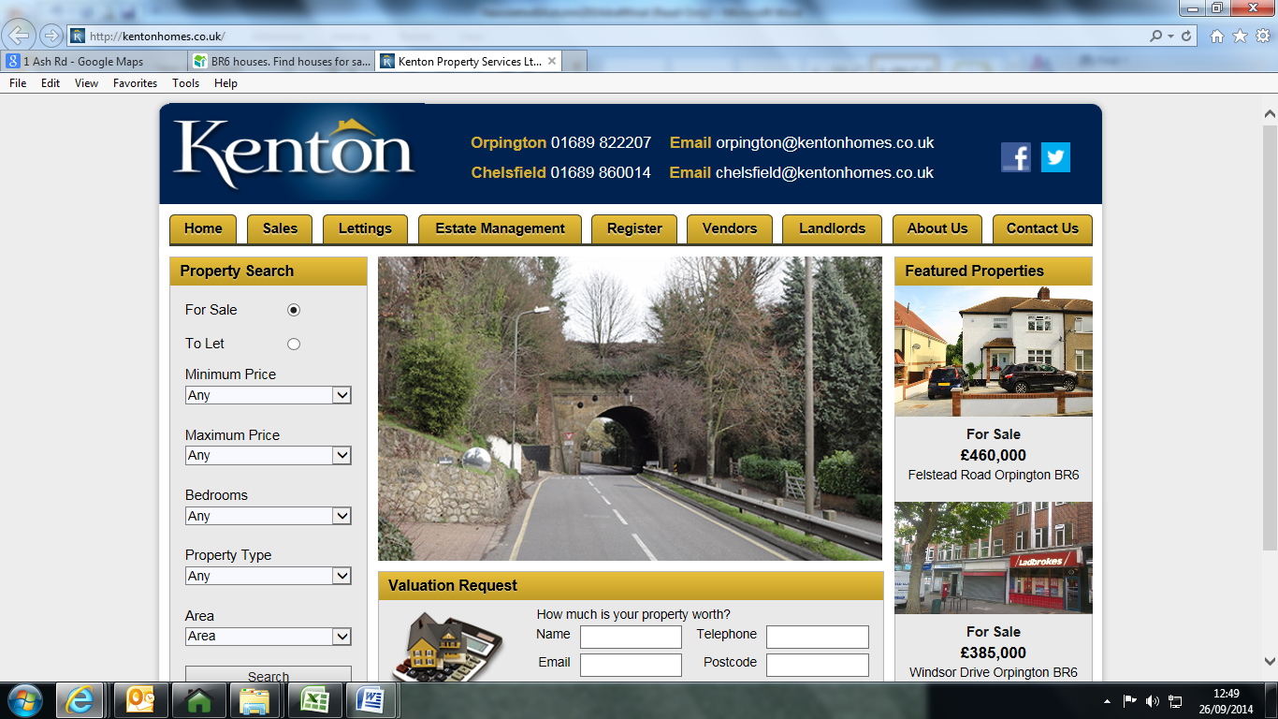

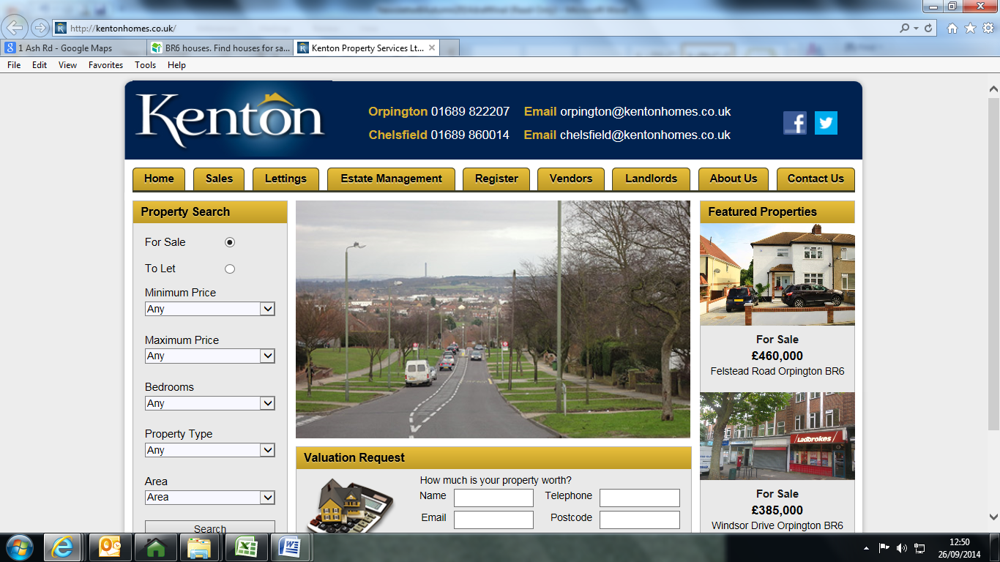

This newsletter was kindly printed by Kenton Estate Agents.

**CHELSFIELD COMMON VIEWPOINT**

Many of you who walk beyond the car park at the junction of The Highway and Warren Road will know of the viewpoint and its amazing view over South East London, the River Thames and beyond. In 1983 the Chelsfield Society provided a stone plinth and an identification map. The map needs updating, also over the years has deteriorated and has become defaced. Warren Road Greenspace Group and Bromley Council are currently updating the map and hope to replace it soon with a new version that will be covered in perspex sheeting to prevent future damage. If you haven’t seen the view its well worth a visit.

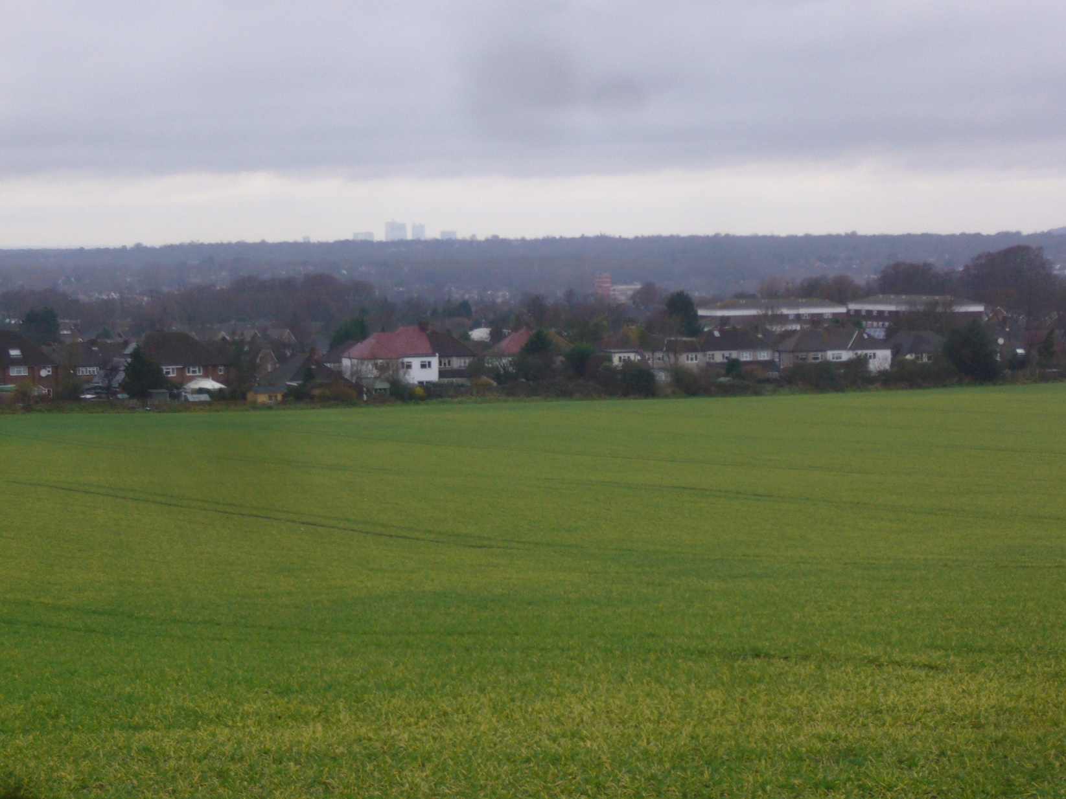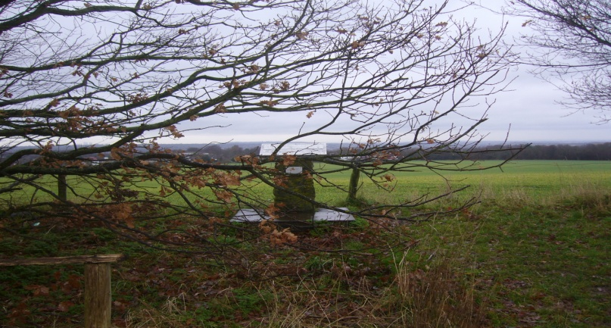

The view from Chelsfield Common

**CHELSFIELD COMMON DIRECT LINE WORKING PARTY**

In July, Direct Line Insurance sent a group of 25 volunteers to help clear the path at Chelsfield Common. The group worked non-stop to cut back hedges (leaving any fruiting branches) and opened the path at the top end of the site. Bromley Council’s Ranger Team worked with our Greenspace Officer, Caroll Long, to clip the cut branches and everyone enjoyed a first class lunch at The Chelsfield pub. Needless to say the afternoon work slowed down a bit! The following week members of our Greenspace Group spread the wood chippings, which are now home to some impressive fungi.

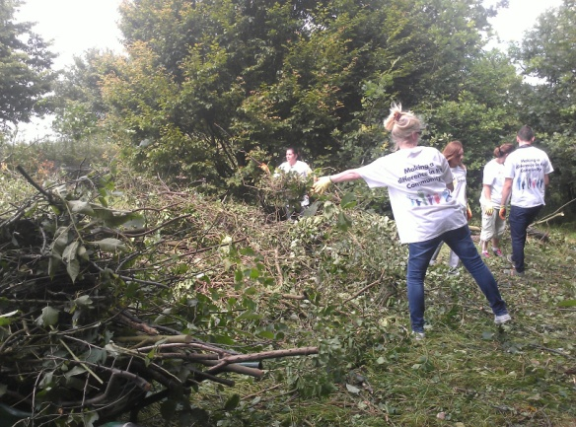

Direct Line working party

**WILDFLOWER MEADOW ON CHELSFIELD COMMON**

[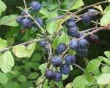](http://www.google.co.uk/url?url=http://nwecotrust.org.uk/?attachment_id=401&rct=j&frm=1&q=&esrc=s&sa=U&ei=YRgcVIKRPMmkPfzGgcgD&ved=0CBwQ9QEwAzg8&usg=AFQjCNEkj-fUy-cGih6No277PsQmqDRK5A)[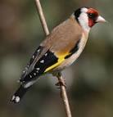](http://www.google.co.uk/url?url=http://www.wildaboutbritain.co.uk/goldfinch&rct=j&frm=1&q=&esrc=s&sa=U&ei=ohYcVNmRDca_OYKEgcgL&ved=0CC4Q9QEwDA&usg=AFQjCNEqx_lmma8Ha3LkC87gM8Mjf48TJA)[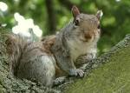](http://www.google.co.uk/url?url=http://caffeinatedthoughts.com/2014/08/squirrels-men/&rct=j&frm=1&q=&esrc=s&sa=U&ei=AhkcVN2KLIGFO6_GgZAC&ved=0CDgQ9QEwEQ&usg=AFQjCNFBF5Yhd7D2slrJAzu79oxk288cgA)Those of you who regularly walk Chelsfield Common behind the car park in The Highway, will already know of its diverse habitat and fantastic foraging opportunities, but those of you who have never visited the site will be missing out on a bountiful and beautiful area with one of Bromley borough’s most fantastic wild flower meadows. This year clovers, thistles, campions, yarrow and cowbane were all in abundance. Add the stunning common orchids into the mix and you can begin to see what a special site this is. Grasses add to the seed mix which is bringing in bird species such as gold and green finches. Many other bird and mammal species benefit from the sheer weight of fruiting hedgerow This includes the human kind who have been known to produce a jar or two of excellent plum jam! Although the show is almost over for this year, it will be well worth a visit in 2015.

Wildlife as seen on Chelsfield Common